2 Medial Sural artery perforator flap [prone]

Flap Territory

The medial sural artery perforator (MSAP) fasciocutaneous flap was first described by Cavadas (2001) as a refinement of the medial gastrocnemius flap. The territory approximates to the medial half of the upper third of the posterior calf ~8x12cm; some say it can extend anteriorly to 2/3rd of the distance from midline to the anterior tibial margin. It is a useful alternative to the radial forearm flap providing thin hairless tissue with relatively little donor site morbidity particularly compared to the posterior tibial artery flap.

Caution should be exercised in those with peripheral vascular disease or diabetes mellitus. An analogous lateral sural artery perforator flap can be raised in most patients as an alternative.

Vascular Anatomy

The MSA usually arises from the popliteal artery (from a common sural trunk in up to 30%). After a few cm, the vessel enters and runs through the medial belly of the gastrocnemius muscle and some branches ‘perforate’ through the skin. The MSA usually divides into lateral and medial branches, this usually occurs in the substance of the muscle (85%). Some prefer to use the lateral (nearer midline) row on the basis that it is usually dominant (Wong 2012). There are other vascular supplies to the muscle apart from the MSA thus muscledevascularisation is not a major worry.

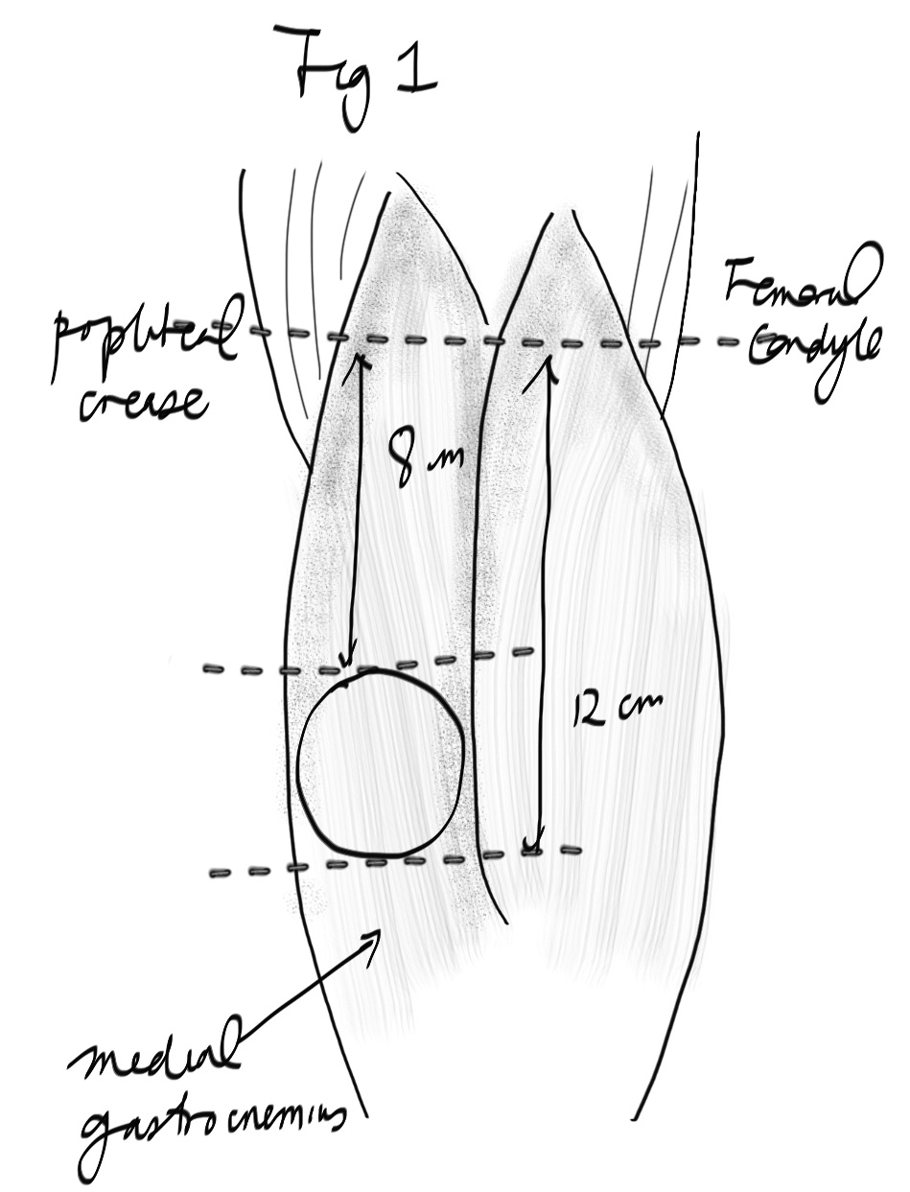

There are usually 2-4 perforators ~1mm diameter that are concentrated at a distance of 10-16cm (Xie 2012 vs 8-13 Lin 2011 vs 5-17.5cm and 4.5 from midline Okamoto 2007) from the popliteal fossa crease; Kim (2006) predicts that the first perforator is usually 8cm along a line drawn from the middle of the popliteal crease to the medial malleolus. Markings should be made with the patient lying on their back and the knee flexed to 90 degrees; note that frog-legging (external rotation of the hip) distorts the skin and vessel positions.
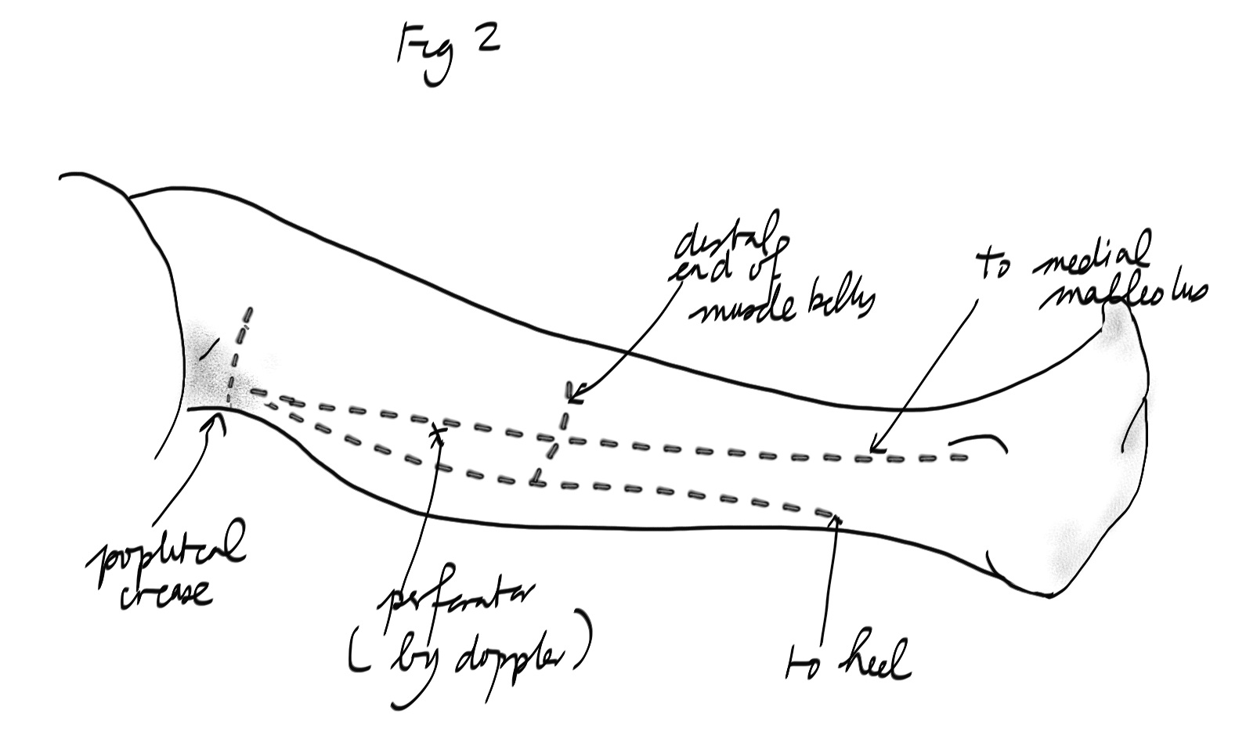

The artery is ~2mm diameter at its origin. Depending on the perforator chosen and amount of retrograde dissection, the pedicle ranges from 9-16cm.
The posterior cutaneous nerve of the thigh can be also harvested in instances where a sensate flap is required.

Flap Harvest

Preoperative examination with a handheld Doppler ultrasound probe or duplex ultrasound can help to locate the perforators (some approximate this to the intersection of the lines from popliteal crease to medial malleolus and medial femoral epicondyle to the lateral malleolus). The flap can be harvested with the patient either supine (frog-legged, for contralateral side) or prone (Wong 2012) – which may be preferable in this dissection course.

In this dissection, the flap territory is taken to be the upper third of the posterior medial calf. A vertical line marks the midline of the posterior calf and the dissection begins here in either the subfascial or suprafascial (more difficult) plane from midline to lateral (in reality, the medial side of leg). Some surgeons start from the anterior border of the flap, which is certainly easier with the patient in the supine position.

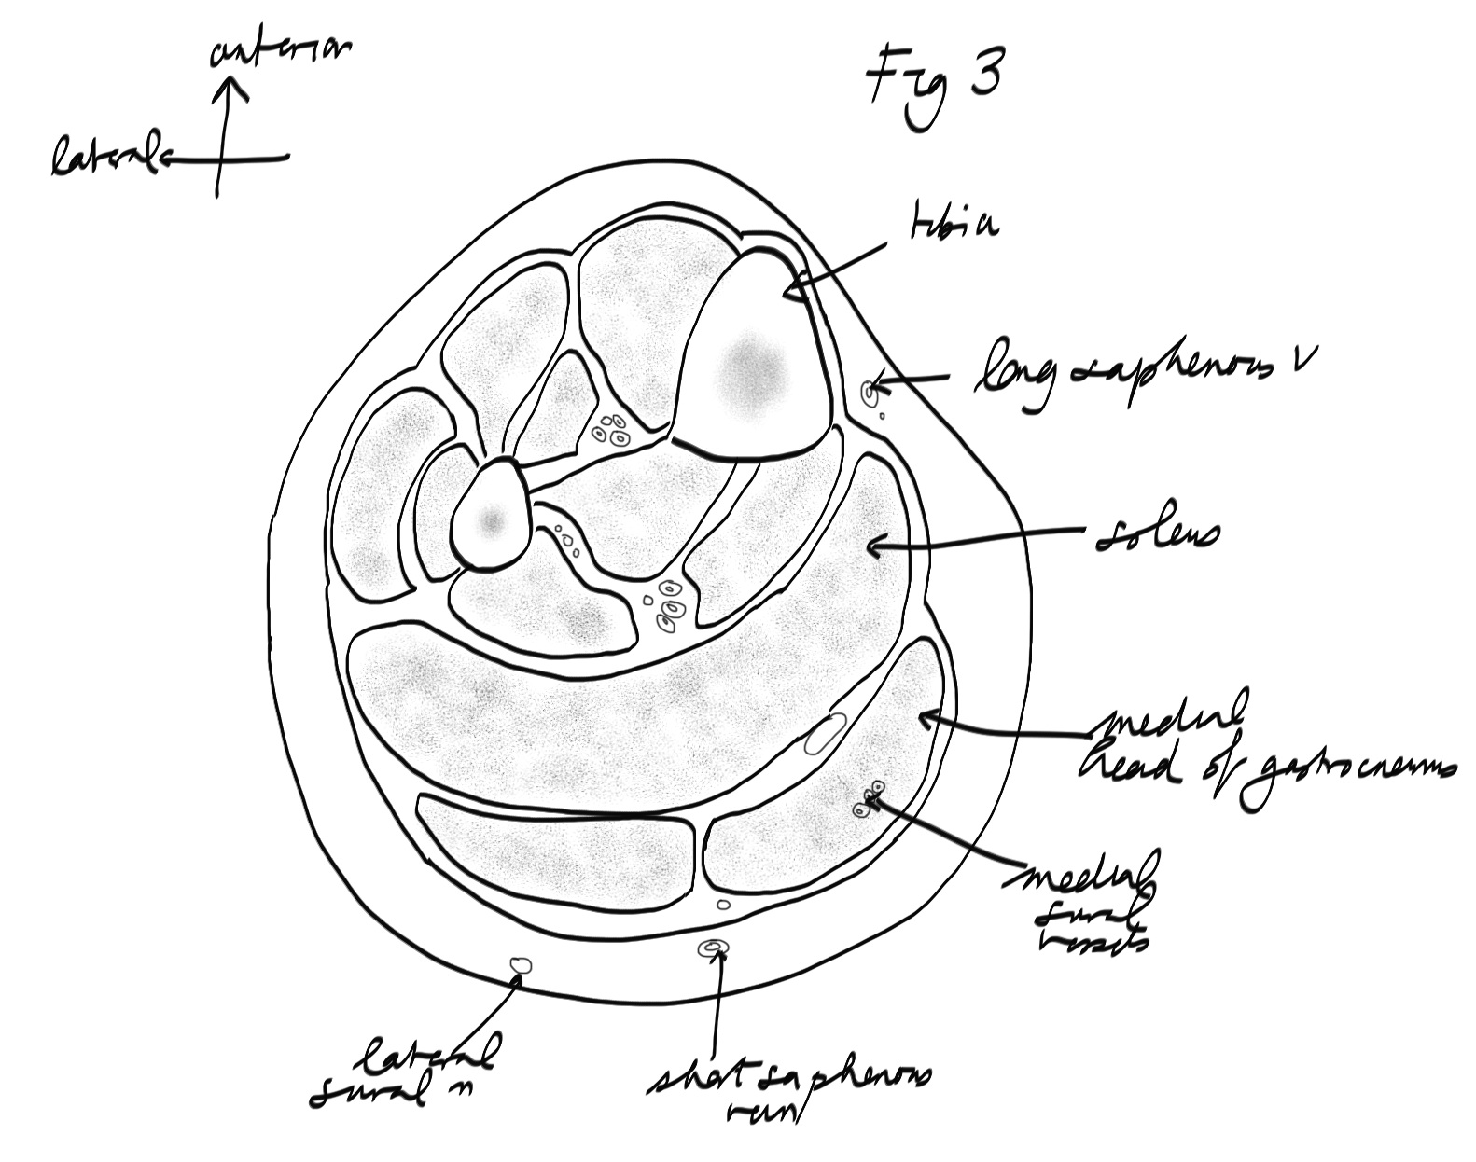
- Perforators are identified; the largest one(s) is chosen and the traced back towards the popliteal artery by splitting the muscle. The other borders of the flap can be incised at this point.

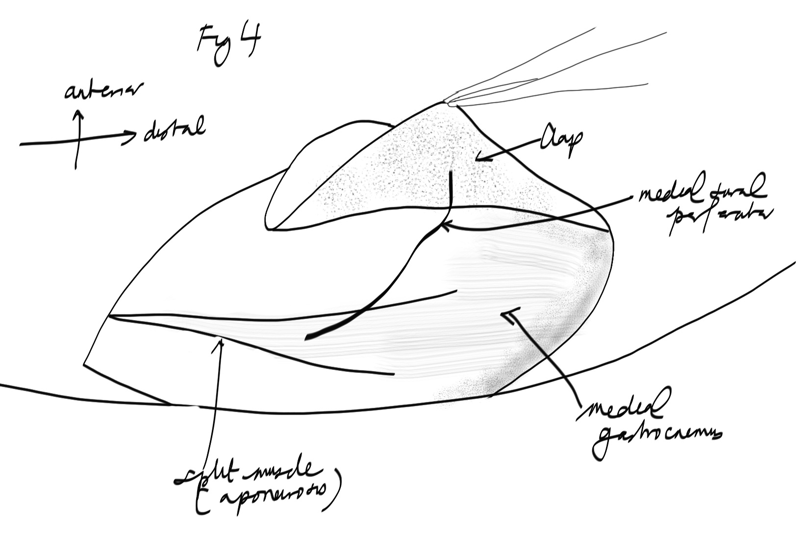
- Take care to spare the motor nerve to the medial belly of the gastrocnemius.
- Some surgeons suggest taking the superficial cutaneous veins (short saphenous) along with the skin paddle for alternate/ additional drainage.
- The donor site can usually be closed directly if 5-6cm or less in width. The muscle surface can be rather aponeurotic and if skin grafts are needed, it may be worthwhile trimming the thick fibrous layer to improve take.

References

Xie XT et al. Medial sural artery perforator flap. Ann Plast Surg 2012;68:105-110

